Your Senior High School

Question/Answer Booklet
Name ______________________________
Teacher ___________________

MATHEMATICS:SPECIALIST 3AB
Semester One Exam 2010
Section Two:
Calculator-assumed

Time allowed for this section
Reading time before commencing work: 5 minutes
Working time for this section: 100 minutes

Materials required/recommended for this section

To be provided by the supervisor
This Question/Answer Booklet
Formula Sheet

To be provided by the candidate
Standard items: pens, pencils, pencil sharpener, eraser, correction fluid, ruler, highlighters
Special items: drawing instruments, templates, and up to three calculators, (CAS, graphic or scientific), which satisfy the conditions set by the Curriculum Council for this course. Up to two (2) A4 pages of notes (handwritten, photocopied or typed on both sides) that may be either personally or commercially produced. It must not be folded, have anything stuck to it or have correction fluid/tape on it.

Important note to candidates
No other items may be used in this section of the examination. It is your responsibility to ensure that you do not have any unauthorised notes or other items of a non-personal nature in the examination room. If you have any unauthorised material with you, hand it to the supervisor before reading any further.

Structure of this paper

Section | Number of questions available | Number of questions to be answered | Suggested working time  (minutes) | Marks available
Section One:  Calculator-free | 11 | 11 | 50 | 40
Section Two:  Calculator-assumed | 14 | 14 | 100 | 80
 |  |  |  | 120
Instructions to candidates

1. Answer the questions according to the following instructions.

Section Two: Write answers in this Question/Answer Booklet. All questions should be answered.
Show all your working clearly. Your working should be in sufficient detail to allow your answers to be checked readily and for marks to be awarded for reasoning. Incorrect answers given without supporting reasoning cannot be allocated any marks.

For any question or part question worth more than two marks, valid working or justification is required to receive full marks.

If you repeat an answer to any question, ensure that you cancel the answer you do not wish to have marked.
It is recommended that you do not use pencil except in diagrams.

2. You must be careful to confine your responses to the specific questions asked and to follow any instructions that are specific to a particular question.

MARK ALLOCATION AND RECORDS:

Section | Question | Marks | Awarded |  | Penalties
TWO | 12 | 3
TWO | 13 | 3 |  |  | Rounding (-1)
TWO | 14 | 6
TWO | 15 | 8 |  |  | Units (-1)
TWO | 16 | 10
TWO | 17 | 7 |  |  | Notation (-1)
TWO | 18 | 4
TWO | 19 | 4
TWO | 20 | 5
TWO | 21 | 5
TWO | 22 | 6
TWO | 23 | 5
TWO | 24 | 8
TWO | 25 | 6
TWO | Penalties | - 1/2/3
 | ONE | 40
 | TWO | 80
 | TOTAL | 120 |  |  | %

Question 12 [3 marks]

Using your graphics calculator or otherwise, solve 4 − |2x| < |2x + 3| + 1.

Question 13 [1, 2 marks]

For g(x) =  − 6 determine each of the following.

(a) g(−4) (b) the value of p for which g(p) = 34

Question 14 [2, 4 marks]

(a) State the natural domain and corresponding range for f(x) = 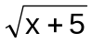.

(b) Find the inverse function for f(x) = 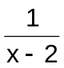 and state the domain and range for this inverse function.
Question 15 [8 marks]

Consider the four graphs shown on the axes below. Use information obtained from the graphs to complete the tables below. Note: Not all equations in the table are graphed and hence it is not possible to find a value for each variable.

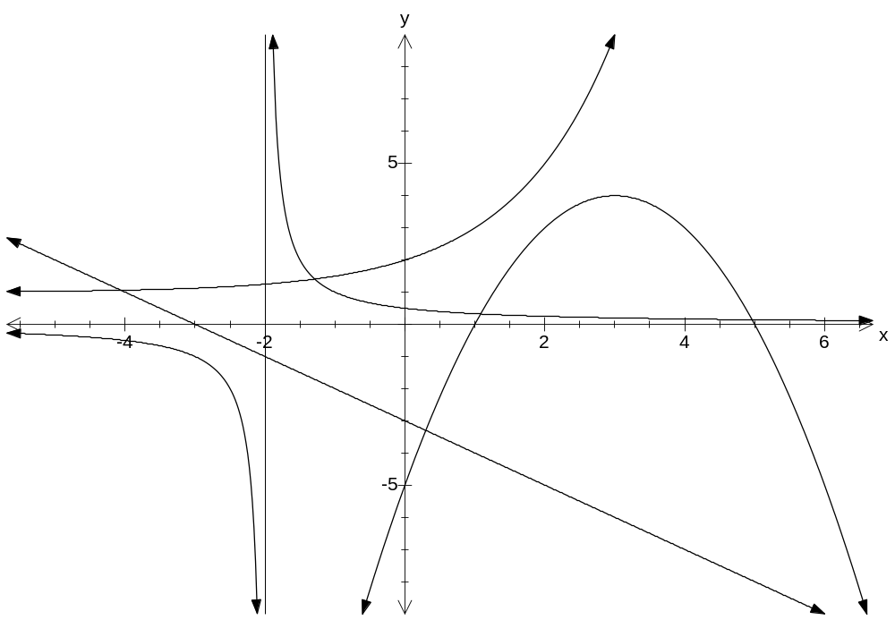
A
C
B
D
(3, 4)
(2, 5)

Equation | Letter label on graph e.g. A |  | Equation | Letter label on graph
y = mx + c |  |  | y = 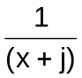+ k
y = log (x + b) |  |  | y = n^{x} + p
y = a(x − d)² + e |  |  | y = |qx + r|

Variable | a | b | c | d | e | j | k | m | n | p | q | r
Value

Question 16 [1, 1, 2, 2, 4 marks]

(a) Write log₃ 5 = x has an exponential statement.

(b) Express 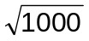 ÷ 10^{−2·5} as a power of 10.

(c) Evaluate log 20 + 2log₂ 17 correct to two decimal places.

(d) Express 2log x + log 7 − log y as a single logarithm.

(e) Solve 5 ^{x − 3} = 2 ^{x + 2} correct to two decimal places showing full working.

Question 17 [1, 1, 5 marks]

A $40 000 car depreciates at a rate of 18% per year for the first four years.

(a) Write down the equation for V, which represents the value of the car after n years.

(b) Using the formula, find the value of the car after 3 years.

(c) The car loses 10% in value during the fifth year.
How much has it lost in value after 5 years?

Question 18 [4 marks]

The concentration of a certain type of pollutant is measured using the formula C = C₀ (0∙88)^{n} where C is the concentration after n filtering processes and C₀ is the original concentration.
How many filtering processes are required before the final concentration is less than 15% of the original concentration?

Question 19 [4 marks]

Determine the magnitude and direction of the resultant force in this system.
8N
12N
30º
Question 20 [5 marks]

If A, B and C have position vectors <7, 2> , <2, −3> and <1, 1> respectively, find a vector in the same direction as 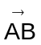 but with the same magnitude as 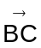.

Question 21 [5 marks]

A trapezium is a polygon with at least one pair of parallel sides. Use vectors to prove that the points A (−4, 6), B (1, 5), C (3, 2) and D (2, −3) form a trapezium.

Question 22 [2, 4 marks]

(a) If V_{A} = 3i − 5j and _{A}V_{B} = 8i + 3j , find V_{B}.

(b) To a person jogging due East at 8 km/h, the wind seems to come from the South with a speed of 5 km/h. Find the true magnitude and direction from which the wind is blowing.

Question 23 [5 marks]
For this question assume that the radius of the Earth is 6350 km.
Jonah leaves his post at Brest, France(48º N,4.5º W) and travels for 5000 km due East. What is the latitude and longitude of his new position?
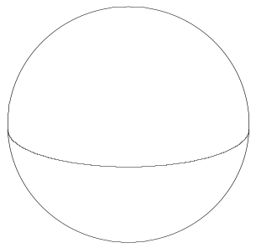
Question 24 [8 marks]

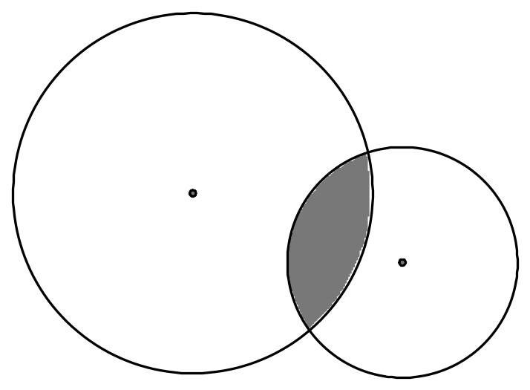In the accompanying diagram, the two radii are 12cm and 16cm and the two centres are 20cm apart. Showing full working, find the perimeter and area of the shaded region. Round your answers to the nearest unit.

Question 25 [2, 4 marks]

Kate is on top of a 28m high cliff. She observes her friend Tim who is due East of the base of the cliff on level ground at an angle of depression of 8º. Kate also observes Jack who is on the same level ground as Tim, on a bearing of 145º from the base of the cliff and at an angle of depression
of 6º.

(a) Draw a diagram to represent the information provided above.

(b) How far apart are Jack and Tim?

MAS 3AB Section Two (Calculator assumed) SOLUTIONS

Question 12 [3 marks]

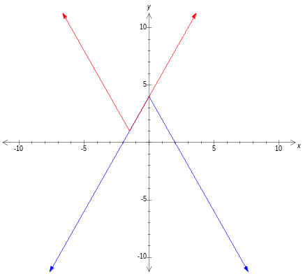Using your graphics calculator or otherwise, solve 4 − |2x| < |2x + 3| + 1.

Solution = {x | x < −1·5 or x > 0 }


Question 13 [1, 2 marks]

For g(x) = − 6 determine each of the following.

(a) g(−4) (b) the value of p for which g(p) = 34

= −7 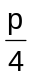 − 6 = 34


= 40
p = 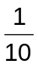


Question 14 [2, 4 marks]

(a) State the natural domain and corresponding range for f(x) = .

D_{x} = { x | x ≥ −5 } R_{y} = { y | y ≥ 0 }



(b) Find the inverse function for f(x) = and state the domain and range for this inverse function.
Let y = D_{x} = { x | x ϵ ӀR, x ≠ 0, x ≠ 2 }

x − 2 = 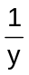 R_{y} = { y | y ϵ ӀR y ≠ 0, y ≠ 2 }

x = + 2

⇒ f ⁻¹ (x) =  + 2
Question 15 [8 marks]

Consider the four graphs shown on the axes below. Use information obtained from the graphs to complete the tables below. Note: Not all equations in the table are graphed and hence it is not possible to find a value for each variable.

A
C
B
D
(3, 4)
(2, 5)

Equation | Letter label on graph e.g. A |  | Equation | Letter label on graph
y = mx + c | D |  | y = + k | A
y = log (x + b) |  |  | y = n^{x} + p | B
y = a(x − d)² + e | C |  | y = |qx + r|

Variable | a | b | c | d | e | j | k | m | n | p | q | r
Value | −1 | x | −3 | 3 | 4 | 2 | 0 | −1 | 2 | 1 | x | x

8 marks ½ mark off for each error

Question 16 [1, 1, 2, 2, 4 marks]
(a) Write log₃ 5 = x has an exponential statement.

5 = 3^{x}

(b) Express ÷ 10^{−2·5} as a power of 10.
= 10^{1·5} . 10^{2·5}

= 10⁴

(c) Evaluate log 20 + 2log₂ 17 correct to two decimal places.

= 9·48

(d) Express 2log x + log 7 − log y as a single logarithm.
= log 7x² − log y

= log 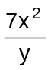


(e) Solve 5 ^{x − 3} = 2 ^{x + 2} correct to two decimal places showing full working.

(x − 3) . log 5 = (x + 2) . log 2

x log 5 − x log 2 = 2 log 2 + 3 log 5
x(log 2∙5) = log (4 x 125)

x = 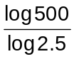

x = 6∙78

Question 17 [1, 1, 5 marks]
A $40 000 car depreciates at a rate of 18% per year for the first four years.
(a) Write down the equation for V, which represents the value of the car after n years.

V = $40000 x (0∙82)^{n}

(b) Using the formula, find the value of the car after 3 years.
V(3) = $40000 x (0∙82)³

= $22054∙72

(c) The car loses 10% in value during the fifth year.
How much has it lost in value after 5 years?

V(5) = V(4) x 0∙9
V(5) = $40000 x (0∙82)⁴ x 0∙9

= $16276∙38
∴Lost value = Original cost − V(5)
= $40000 − $16276∙38

= $23723∙62
Question 18 [4 marks]

The concentration of a certain type of pollutant is measured using the formula C = C₀ (0∙88)^{n} where C is the concentration after n filtering processes and C₀ is the original concentration.
How many filtering processes are required before the final concentration is less than 15% of the original concentration?

Let C = 0∙15 C₀
⇒ 0∙15 C₀ = C₀ (0∙88)^{n}

⇒ log (0∙15) = n log (0∙88)
n = 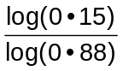

= 14∙84

∴ 14 processes not enough, 15 processes required.

Question 19 [4 marks]

Determine the magnitude and direction of the resultant force in this system.
8N
12N
30º

R² = 8² + 12² − 2.8.12.cos 60º
8N
12N
60º
60º
θ
R

R = 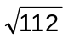N

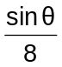 = 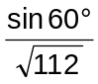

θ = 41º (nearest degree)

∴ Magnitude of resultant force is N

with a bearing of 259º

Question 20 [5 marks]
If A, B and C have position vectors <7, 2> , <2, −3> and <1, 1> respectively, find a vector in the same direction as but with the same magnitude as .
= <2, −3> − <7, 2>

= <−5, −5>
|| = 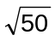


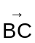 = <1, 1> − <2, −3>

= <−1, 4>
|| = 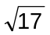


∴ V = 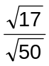 <−5, −5>


Question 21 [5 marks]

A trapezium is a polygon with at least one pair of parallel sides. Use vectors to prove that the points A (−4, 6), B (1, 5), C (3, 2) and D (2, −3) form a trapezium.
A
B
C
D
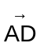 = <2, −3> − <−4, 6>

= <6, −9>
= <3, 2> − <1, 5>

= <2, −3>
Now = <6, −9>

= 3 <2, −3>
which is a scalar multiple of .


∴ is parallel to and so ABCD forms a trapezium.

Question 22 [2, 4 marks]

(a) If V_{A} = 3i − 5j and _{A}V_{B} = 8i + 3j , find V_{B}.

<8, 3> = <3, −5> − <x, y>
<x, y> = <3, −5> − <8, 3>
= <−5, −8>

i.e. V_{B} = −5i + −8j

(b) To a person jogging due East at 8 km/h, the wind seems to come from the South with a speed of 5 km/h. Find the true magnitude and direction from which the wind is blowing.
8 km/h
V_{jog}
θ
5 km/h
_{wind}V_{jog}
V_{wind}
_{wind}V_{jog} = V_{wind} − V_{jog}
∴ V_{wind} = V_{jog} + _{wind}V_{jog}

| V_{wind}| = 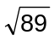


Tan θ = 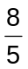

θ = 58° (blowing to)

∴ Magnitude is and the wind is blowing from 238°.

Question 23 [5 marks]
For this question assume that the radius of the Earth is 6350 km.
Jonah leaves his post at Brest, France(48º N,4.5º W) and travels for 5000 km due East. What is the latitude and longitude of his new position?
Latitude radius = r_{e} cos 48°

= 4249 km (nearest km)
A = r θ
θ = 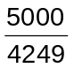

= 1∙177 radians

≈ 67∙4°
∴ Latitude = 48° N and Longitude = 62∙9° E



Question 24 [8 marks]

In the accompanying diagram, the two radii are 12cm and 16cm and the two centres are 20cm apart. Showing full working, find the perimeter and area of the shaded region. Round your answers to the nearest unit.
α
θ
16 cm
12 cm
20 cm
L
S

12² + 16² = 400
= 20²

∴ Right-angled triangle.
Tan θ = 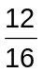
θ = 36∙9°

2θ = 1∙288 radians

α = 90° − 36∙9°
α = 53∙1°

2α = 1∙854 radians

Area
A_{T} = Segment_{L} + Segment_{S}
= (16²) (1∙288 − sin (1∙288) ) + (12²) (1∙854 − sin (1∙854) )



= 41∙948 + 64∙356

= 106 cm² (nearest unit)

Perimeter
P_{T} = Arc_{L} + Arc_{S}

= 16 x 1∙288 + 12 x 1∙854

= 43 cm (nearest unit)

Question 25 [2, 4 marks]

Kate is on top of a 28m high cliff. She observes her friend Tim who is due East of the base of the cliff on level ground at an angle of depression of 8º. Kate also observes Jack who is on the same level ground as Tim, on a bearing of 145º from the base of the cliff and at an angle of depression
of 6º.

(a) Draw a diagram to represent the information provided above.

Kate
N

28 m

8°
Tim
x
55°
y
6°
d

Jack

(b) How far apart are Jack and Tim?

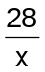 = Tan 8°

x = 199∙23 m

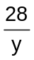 = Tan 6°

y = 266∙4 m

d² = 199∙23² + 266∙4² − 2 . 199∙23 . 266∙4 . cos 55°

∴ d = 223∙1 m

